Press release

Bad Zwischenahn, 22. Januar 2025

Successful premiere all round

Hüppe is very satisfied with its appearance at ‘BAU 2025’ - New Hüppe Sphere impresses

This year, Ammerland-based shower specialist Hüppe (www.hueppe.com) exhibited for the first time at ‘BAU’ in Munich, the world's leading trade fair for architecture, materials and systems. The focus of its appearance from 13 to 17 January 2025 in the Bavarian capital was Hüppe Sphere, the first series of a completely new product category that will be available from summer 2025. The dedicated Hüppe team was able to present and explain the new product to over 500 registered national and international trade fair contacts from architecture and planning offices, housing associations and property developers as well as wholesale and trade companies at its premiere. ‘But we didn't have to explain very much. Our trade fair guests quickly realised that Hüppe Sphere redefines the shower,’ says a delighted Axel Stoiber, Managing Director of the newly founded Hüppe Deutschland GmbH, who hosted the trade fair for the sanitary company in Munich. ‘The fact that Hüppe Sphere sets new standards with its added materiality, colours, functions and modularity by opening up smart and creative possibilities for individual room design in bathroom architecture was a complete success. Our double premiere was a complete success.’

Really intelligent!
Hüppe presented three variants of the new product family at ‘BAU’. However, their modular design allows for far more different and extremely easy-to-configure solutions to make more of the bathroom's interior design. With a largely freely configurable combination of glass and solid surface modules in different surfaces, which are embedded in a metal support system, Hüppe Sphere also brings a previously unknown variety of materials and colours to the shower area. The optional integration of light and - in the near future - heat also creates a completely unique atmosphere in the shower area. ‘The shower experience is no longer determined by the water alone, but to a large extent by this spatial atmosphere,’ explains Axel Stoiber. ‘Hüppe Sphere also emphasises the growing importance of the shower for our well-being in architectural terms.’

What's more, Hüppe Sphere integrates a variety of convenient and intelligent functions according to personal wishes and requirements. The spectrum ranges from various accessories and storage systems to a spacious, discreetly illuminated storage niche, the Hüppe Wallbox and lighting and heating systems, which can also be integrated into standard smart home systems via a binary IO interface if required. In contrast to conventional shower enclosures, Hüppe Sphere also uses the outside to accommodate useful functions such as mirrors, towel rails, towel warmers, shelves or furniture, making the modular system solution a central interior design element in the bathroom. This also opens up completely new approaches for the design of the room layout. A major advantage for planning and implementation is that, thanks to Hüppe Sphere's innovative frame profile, which allows an adjustment range of up to eight centimetres, shower areas can be planned in most projects without the need for measurements. This significantly reduces both planning and installation costs.

‘The consistently positive response to Hüppe Sphere during ‘BAU’ shows us,’ emphasises Axel Stoiber, ’that this new product category has the potential to give interior design strong creative impetus and to establish a new era in bathroom architecture - and to make Hüppe the number one in the shower area market once again.’

Detailed information on Hüppe Sphere and important planning data are available online:
www.hueppe.com/new-era/

***

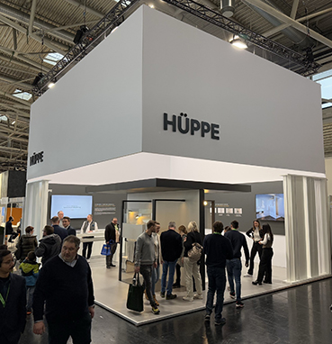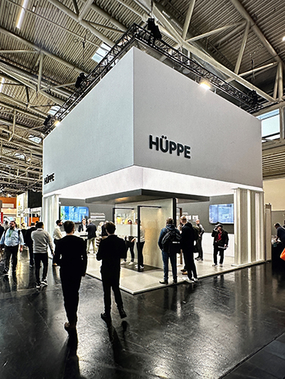

Successful premiere: Hüppe exhibited for the first time this year at ‘BAU’ in Munich, which is one of the most important meeting places for the construction industry with over 2,200 exhibitors from 58 countries. With Hüppe Sphere, the company's most important innovation since Claus Hüppe pioneered the shower enclosure in Europe in the mid-1960s, the Ammerland-based shower space is setting new standards for the industry.© Hüppe GmbH
[HUEPPE_BAU 2025_Stand_01.jpg und HUEPPE_BAU 2025_Stand_02.jpg]

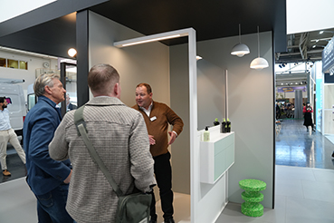

‘Our trade fair guests quickly realised that Hüppe Sphere completely redefines the shower,’ says a delighted Axel Stoiber (r.), Managing Director of Hüppe Deutschland GmbH. ‘The fact that Hüppe Sphere opens up completely new, smart and creative possibilities for individual room design thanks to the added materiality, colours, functions and modularity of the bathroom architecture was met with enthusiasm across the board.’© Hüppe GmbH
[HUEPPE_BAU 2025_Axel Stoiber_Beratung_1.jpg]

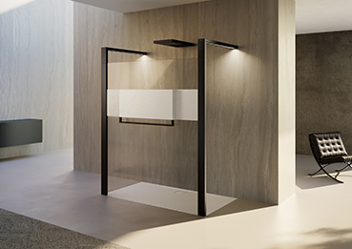

A new era in bathroom architecture: Hüppe Sphere completely redefines the shower area and the bathroom. The combination of glass and solid surface modules in different surfaces and colours provides interior designers with numerous additional options for individual room design.
© Hüppe GmbH
[Hüppe Sphere_01b.jpg]

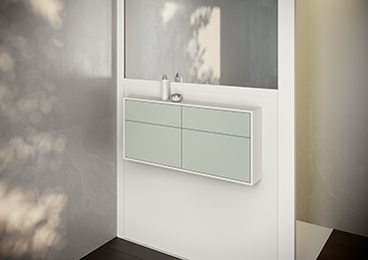

Quite ingenious: In contrast to conventional shower enclosures, Hüppe Sphere opens up a wide range of options for using the outside to integrate useful functions such as mirrors, towel rails, towel warmers, shelves or furniture. functions such as mirrors, towel rails, towel warmers, shelves or furniture. © Hüppe GmbH
[Hüppe Sphere_Möbel-closeup_06.jpg]

***

About Hüppe - the shower specialist
Hüppe GmbH, headquartered in Bad Zwischenahn, specialises in innovative solutions for the entire shower area in the modern bathroom. Founded in 1889 by Justin Hüppe, the company has been one of Europe's leading manufacturers of shower enclosures, shower trays, wall panelling and shower accessories since it pioneered shower enclosures in Europe in 1966, laying the foundations for a new product category. Since then, Hüppe has built up a reputation as one of the leading international high-end brands for the shower sector thanks to numerous pioneering innovations such as the Keder system, the particularly easy-to-clean anti-plaque glass surface and the patented screw-free installation for wall panelling. Hüppe not only scores with solutions that set standards with their premium quality ‘Made in Germany’, maximum individual design freedom, excellent design and customer benefits, but also with first-class service quality. It is no coincidence that Hüppe products can be found in numerous renowned projects such as the luxurious Ushuaïa ‘Ibiza Beach Hotel’, the giant cruise liner ‘AIDAnova’, the 5-star residence ‘Sapphire House’ in Antwerp and the ‘Skyland’ residential towers in Istanbul.

Hüppe employs around 450 people, 240 of whom work in Germany. The company produces at its headquarters in Bad Zwischenahn and in Kapaklı/Tekirdağ, Turkey (west of Istanbul). Hüppe GmbH has been part of the Aurelius Group since 2021.
***

Press Contakt
KommunikationsKonsortium
Dr. Carsten Tessmer
T + 49 4462 209 6683/209 6685
M + 49 160 991 36380
press@hueppe.com
hueppe@kommunikationskonsortium.com

