Press Release

Munich /Bad Zwischenahn, 13. Januar 2025

Really intelligent!

Hüppe Sphere establishes a new era in bathroom architecture with all-round smart solutions

‘With Hüppe Sphere, we are laying the foundation for a completely new product category that redefines the shower area and the bathroom,’ explains Christopher Tattersall, who is responsible for product management and product development at Ammerland-based shower area specialist Hüppe (www.hueppe.com). With more intelligent functions, materials, modularity and options for individual room design, the modular Hüppe Sphere system makes the shower area the centrepiece of bathroom architecture. ‘We are taking the shower area out of its niche and transforming it into a central, all-round smart interior design element in the architecture of the home, which also architecturally emphasises the growing importance of the shower for our well-being and does not just reduce it to the water experience. At the same time, Hüppe Sphere contributes to a quality of design and living in the bathroom that is in no way inferior to that in other areas of our living environment,’ says designer Michael Stein, describing his vision. Together with the Hüppe team, he has developed the new product category and, with Hüppe Sphere, its first product family, which will be available from summer 2025.

In fact, the benefits and functions of Hüppe Sphere go far beyond what conventional shower enclosures are capable of. This is made possible by the use of materials that offer an alternative to conventional glass, a completely new design of the frame profile and the large number of functions that can be integrated both inside and out - from useful accessories, lighting systems and, in the near future, heating elements to furniture, mirrors and integration into common smart home systems.

More materiality, more colour, more individuality
Hüppe Sphere brings a previously unknown variety of materials and colours to the shower area. Hüppe Sphere combines modules made of glass and the natural, extremely pleasant to the touch Solid Surface mineral material in a support system made of metal profiles. Various combinations can be realised: from a completely closed partition wall to partially transparent versions and even a pure real glass front - depending on the degree of intimacy desired.

The fact that the modules made of high-quality solid surface material are available in different colours and - like the glass modules - in different surface textures is crucial for the interior design and spatial effect. They are available in anthracite, snow and cream as standard. The modules can also be produced in other surface colours on request. In addition, Hüppe's own surface finishing department coats the metal profiles of the support system and accessories such as the towel rail in all RAL colours - including the particularly popular colours ‘Black Edition’ (matt black), ‘White Edition’ (matt white), ‘Gold Edition’ and in the metallic surfaces bronze, black chrome, brass and stainless steel look. The glass modules are also available in different colours. The fronts of the furniture that can be integrated on the outside of Hüppe Sphere are also available in different surfaces and colours: in addition to the standard surfaces of alpine white, light grey and oak look, other colour designs are also available on request.

Hüppe Sphere therefore provides interior designers with a whole new range of additional options to create a harmonious room atmosphere in line with the furnishing style and design preferences or to set exciting accents in the room with attractive eye-catchers. ‘Hüppe Sphere allows you to make more of the room,’ emphasises designer Michael Stein. ‘The creative minds in architecture and interior design have countless possibilities to design the bathroom with a series product entirely according to the personal wishes of their customers and make individual living dreams come true. The bathroom thus becomes even more of a strong expression of one's own personality.’

More room design, more comfort, more flexibility
This is all the more true as Hüppe Sphere opens up completely new approaches to the design of the room layout. In contrast to conventional shower enclosures, the modular system also utilises the outside to integrate useful functions such as mirrors, towel rails, towel warmers, shelves or furniture. In this way, Hüppe Sphere combines the ‘I’ area of the bathroom, which is intended for personal wellness and intimate body care, with the ‘we’ area, where togetherness and mutual interaction take place. Where generous planning is possible, Hüppe Sphere is therefore ideal for zoning and separating rooms - without the need for walls or partitions to be erected in a time-consuming process involving several trades. Innovative room concepts can be realised with Hüppe Sphere, especially where flowing transitions into other areas of the home are to be created beyond conventional solutions.

On small floor plans - for example in the context of micro living - Hüppe Sphere takes on the role of a central furnishing object. This is because the system is extremely smart and sophisticated in everyday living, integrating a wide range of convenient functions on both the inside and outside and fulfilling the highest standards of functionality in the bathroom. These include various accessories and storage systems, from a towel holder and simple tray to a spacious, discreetly illuminated storage niche, the Hüppe Wallbox, in which various shower utensils can be stored within easy reach, through to various items of furniture and mirrors on the outside. Optional LED lighting systems integrated into crossbars and wall profiles as well as the Hüppe Wallbox, whose light intensity and colour can be controlled via a touch display, create a pleasant atmosphere in the room. In future, integrated heating foils, which can also be operated at the touch of a finger on the extended display, will also ensure that the shower area is always at a pleasant temperature and that towels hanging on the outside are warmed. Even greater ease of use is possible by integrating the lighting and heating elements into standard smart home systems via a binary IO interface. ‘With Hüppe Sphere, the functionalities that enhance shower comfort and increase the quality of time spent in the bathroom can be flexibly determined according to individual needs and wishes,’ says Hüppe Head of Product and Development Tattersall.

Hüppe Sphere offers even more flexibility, because the modular system can be used to create different shower space solutions in various dimensions from just a few components - entirely according to personal requirements and structural specifications: from the trendy walk-in shower with wall or ceiling connection to the free-standing walk-through version and the closed shower enclosure with door system. The modularity makes it extremely easy to understand the system and put together the desired solution. There is a choice of three equipment variants: While the ‘Pure’ models focus exclusively on the shower, the ‘Living’ and ‘Individual’ versions make use of the options that Hüppe Sphere offers for the individual design of the bathroom interior - the latter with surfaces and colours that go beyond the standard range to fulfil almost every design wish. Alternatively, three pre-configured variants will also be available by the end of the year. Shower space solutions with Hüppe Sphere can already be planned now: The necessary planning data and a configurator are available immediately.

More efficiency, more planning reliability, more cost-effectiveness
A major advantage for planning and implementation is that, thanks to the new Hüppe Sphere frame profile, which allows an adjustment range of up to eight centimetres, shower areas can be planned in most projects without the need for measurements. This significantly reduces both planning and installation costs - while at the same time improving planning reliability. The modular design also makes transport and installation easier. Instead of large and correspondingly heavy glass panes in one piece, much smaller and lighter modules are transported and installed. In addition, the modular system ensures that installation is quick and safe - but also consistently precise, as Hüppe Sphere can be perfectly adapted to different room conditions almost anywhere thanks to the generous tolerance range. This eliminates the need for time-consuming, millimetre-precise customisation, as is the case with conventional shower enclosures, meaning that all components can be produced in series. The double benefit: even large-scale projects can be supplied in top quality in a short space of time, and installation times are reduced compared to conventional partitions.

‘This concentrated added value is the result of our strictly user-orientated understanding of innovation and development approach,’ Michael Stein and Christopher Tattersall agree. Indeed, Hüppe Sphere uniquely fulfils the needs of architecture, interior design, the property industry and trade, as well as those of users. It is no coincidence that the shower specialist from Bad Zwischenahn considers Hüppe Sphere to be the most important new development from its creative department since Claus Hüppe pioneered the shower enclosure on the market in Europe in the mid-1960s. Just as almost 60 years ago, when the then new product category replaced and increasingly superseded the previously common shower curtain, the new product category with its first product series Hüppe Sphere also has the potential to give interior design strong creative impetus and establish a new era in bathroom architecture.

***

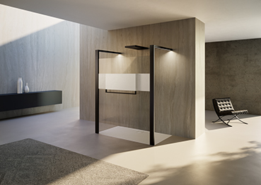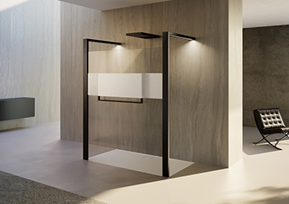

A new era in bathroom architecture: Hüppe Sphere completely redefines the shower area and the bathroom. The combination of glass and solid surface modules in different surfaces and colours provides interior designers with numerous additional options for individual room design.
© Hüppe GmbH
[Hüppe Sphere_01a.jpg und Hüppe Sphere_01b.jpg]

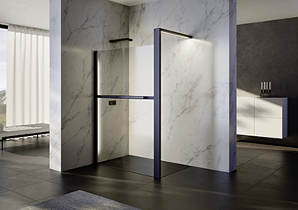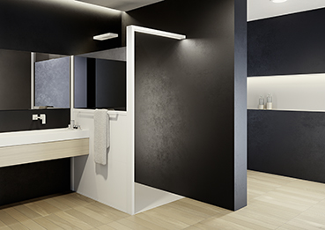

Bathroom living space: The new materiality of Hüppe Sphere, in combination with the clear, linear design, creates an aesthetic of timeless elegance that makes the bathroom a permanently attractive living space. Surfaces that are pleasant to the touch and the use of light create an inviting ambience with a high quality of stay.
© Hüppe GmbH
[Hüppe Sphere Pure_02a.jpg und Hüppe Sphere Living_02b.jpg]

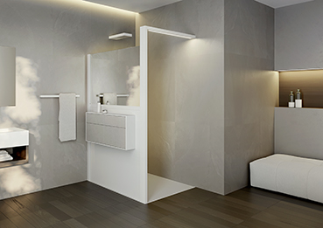

All-round feel-good experience: The use of solid surface material brings a materiality and colourfulness to the shower area that radiates cosy warmth and homeliness. This is all the more true as the optional integration of light and warmth creates an atmosphere in the shower area that appeals to all the senses and emotionally enriches the shower room.
© Hüppe GmbH
[Hüppe Sphere Living_03.jpg]

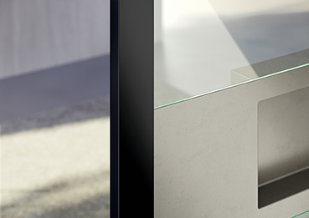

Special material: Solid Surface, which is made from mineral stone, colour pigments and acrylic, is characterised by its pleasant feel. It is also non-porous, particularly hygienic and easy to clean. It is characterised by its impact and scratch resistance as well as its resistance to UV radiation, heat, moisture and chemicals. Due to its relatively low CO2 footprint, it is rated as environmentally friendly.
© Hüppe GmbH
[Hüppe Sphere_Materialien_04.jpg]

Generous storage space: The discreetly illuminated Hüppe Wallbox module from Hüppe Sphere provides ample space within easy reach for all the shower utensils you need. Additional storage and organiser accessories are also available.
© Hüppe GmbH
[Hüppe Sphere_Wallbox beleuchtet_05.tiff]

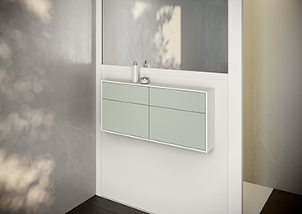

Quite ingenious: In contrast to conventional shower enclosures, Hüppe Sphere opens up a wide range of options for integrating helpful functions such as mirrors, towel rails, towel warmers, shelves or furniture on the outside.
© Hüppe GmbH
[Hüppe Sphere_Möbel-closeup_06.jpg]

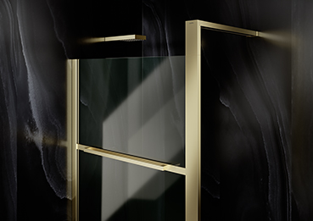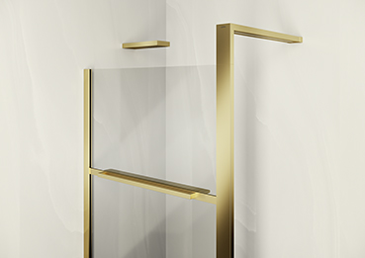

Individual design: Hüppe Sphere brings more colour into the bathroom than conventional shower enclosures. Not only are the solid surface modules available in different colours and textures, but you can also choose between different colours for the glass, furniture fronts and metal profiles.
© Hüppe GmbH
[Hüppe Sphere_Gold_07a.jpg und Hüppe Sphere_Gold_07b.jpg]

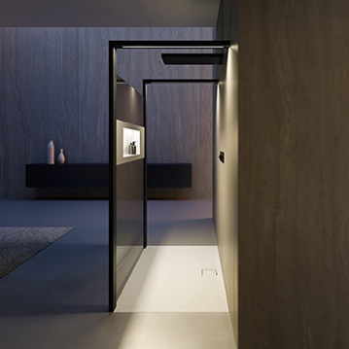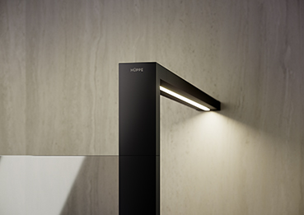

More atmosphere: optionally integrated lighting systems, whose light intensity and colour can be continuously controlled from daylight white (6,700 Kelvin) to warm white (2,500 Kelvin), ensure sufficient lighting and a pleasant room atmosphere at all times.
© Hüppe GmbH
[Hüppe Sphere_LED-Beleuchtung_08a.tiff, Hüppe Sphere_LED-Beleuchtung_08b.jpg und Hüppe Sphere_LED-Beleuchtung_08c.jpg]

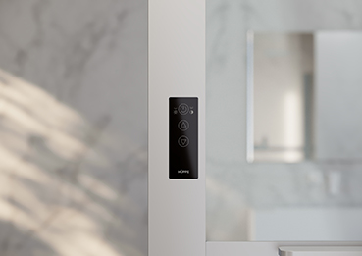

Intelligently networked: The LED lighting systems integrated into the frame profile and the Hüppe Wallbox and the heating elements, which will also be available in the future, are controlled via a touch display. Light and heating functions can also be integrated into standard smart home systems via a binary IO interface.
© Hüppe GmbH
[Hüppe Sphere_Touch-Bedienfeld_09.jpg]

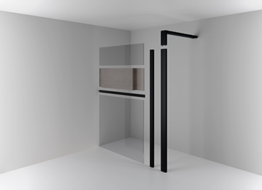

More flexibility: Modular design, free combination options of glass and solid surface in various colours and surfaces, a wide range of functionalities - Hüppe Sphere allows you to create a variety of shower area solutions in different dimensions.
© Hüppe GmbH
[Hüppe Sphere_Module_Explosion_10.jpg]

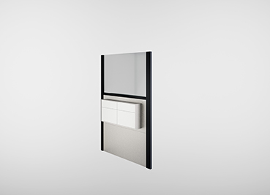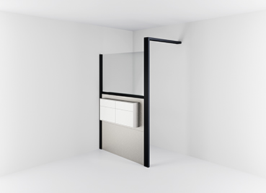
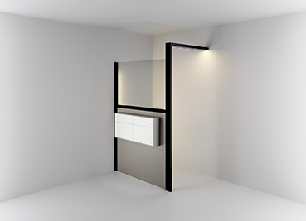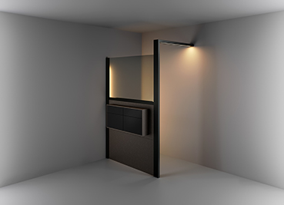

Four steps to the shower area of tomorrow: the modular structure of Hüppe Sphere makes it easy to understand the system and configure the desired shower area solution yourself - taking into account the three equipment variants ‘Pure’, ‘Living’ and ‘Individual’, the structural conditions, the required functions and the desired look and feel. Alternatively, three completely pre-configured variants will also be available in the course of the year.
© Hüppe GmbH
[Hüppe Sphere_Konfiguration Step 1_11a.jpg, Hüppe Sphere_Konfiguration Step 2_11b.jpg, Hüppe Sphere_Konfiguration Step 3_11c.jpg und Hüppe Sphere_Konfiguration Step 4_11d.jpg]



‘My vision was to make the shower area the centrepiece of bathroom architecture with more intelligent functions, materials, modularity, a feel-good experience and options for individual interior design. With Hüppe Sphere, the shower area is finally no longer a wet room, but an all-round smart design and feel-good element in the architecture of the home,’ says designer Michael Stein, describing his idea behind the development of the new product category and its first product family, Hüppe Sphere.
© Michael Stein Design
[2025_Hüppe_Michael Stein.jpg]



‘With Hüppe Sphere, we are laying the foundation for a completely new product category that redefines the shower area and the bathroom. With its multitude of smart solutions, it will provide interior design with strong creative impetus and establish a new era in bathroom architecture,’ says Christopher Tattersall, Head of Product Management and Product Development at Hüppe.
© Hüppe GmbH
[2025_Hüppe_Christopher Tattersall.jpg]

***

About Hüppe - the shower space specialist
Hüppe GmbH, headquartered in Bad Zwischenahn, specialises in innovative solutions for the entire shower area in the modern bathroom. Founded in 1889 by Justin Hüppe, the company has been one of Europe's leading manufacturers of shower enclosures, shower trays, wall panelling and shower accessories since it pioneered shower enclosures in Europe in 1966, laying the foundations for a new product category. Since then, Hüppe has built up a reputation as one of the leading international high-end brands for the shower sector thanks to numerous pioneering innovations such as the Keder system, the particularly easy-to-clean anti-plaque glass surface and the patented screw-free installation for wall panelling. Hüppe not only scores with solutions that set standards with their premium quality ‘Made in Germany’, maximum individual design freedom, outstanding design and customer benefits, but also with first-class service quality. It is no coincidence that Hüppe products can be found in numerous renowned projects such as the luxurious Ushuaïa ‘Ibiza Beach Hotel’, the cruise liner ‘AIDAnova’, the 5-star residence ‘Sapphire House’ in Antwerp and the ‘Skyland’ residential towers in Istanbul.

Hüppe employs around 450 people, 240 of whom work in Germany. The company produces at its headquarters in Bad Zwischenahn and in Kapaklı/Tekirdağ, Turkey (west of Istanbul). Hüppe GmbH has been part of the Aurelius Group since 2021.

***

Press Contact
KommunikationsKonsortium
Dr. Carsten Tessmer
T + 49 4462 209 6683/209 6685
M + 49 160 991 36380
press@hueppe.com
hueppe@kommunikationskonsortium.com

